**Data Modelling in Qlik Sense**

* Qlik offers a flexible and powerful data model for creating business intelligence solutions.
* The data model in Qlik consists of data tables and fields, and it allows for the creation of associations between tables that enable users to navigate data dynamically.
* Qlik’s data model is based on an in-memory technology that allows for rapid processing and analysis of large data sets.
* This technology also enables users to combine data from multiple sources and create data models that are tailored to their specific needs.
* Qlik’s data model supports a variety of data types, including numeric, text, and date/time fields, and it provides a wide range of functions for manipulating and analyzing data.
* Qlik also offers a scripting language that enables users to create custom data models and perform advanced data transformations.
* In addition to its core data modeling capabilities, Qlik provides a range of features for managing data security, optimizing data performance, and integrating with other data sources.
* These features make Qlik a powerful platform for building data-driven applications that enable users to make informed decisions based on real-time data insights.

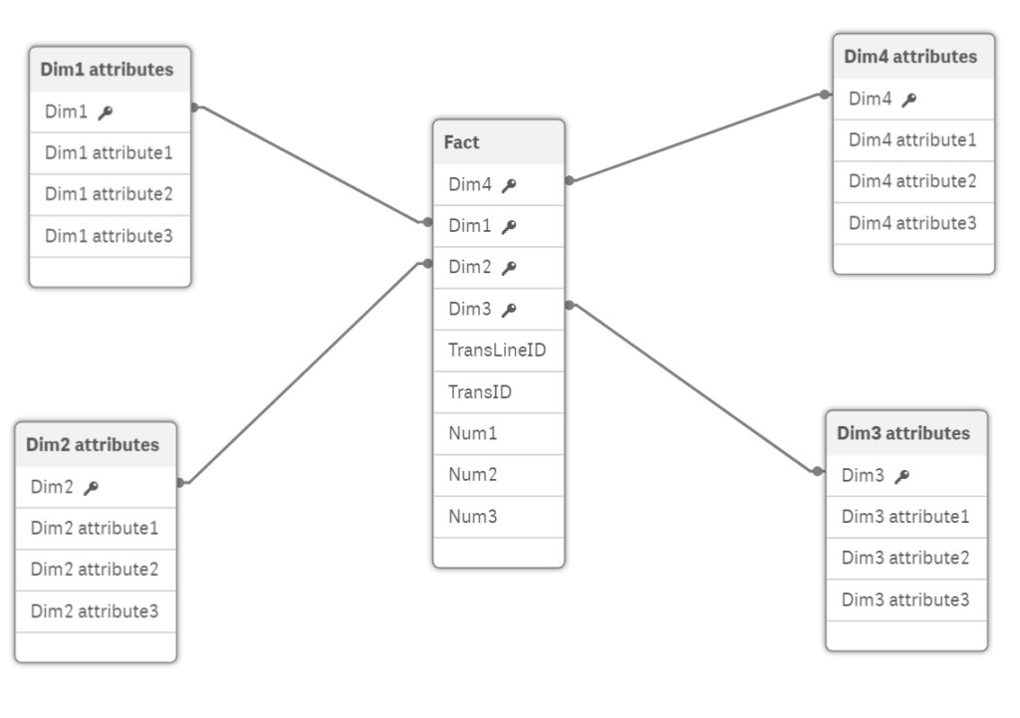

**Star schema**

In Qlik, there are mainly two types of data models:

1. Relational Data Model: This type of data model is based on the traditional relational database structure, where data is organized in tables with columns and rows. In Qlik, users can create a relational data model by loading data from various sources and creating a table structure that reflects the relationships between them. Qlik’s associative engine then automatically creates the necessary associations between tables, allowing users to explore data and make data-driven decisions.

In Qlik, there are two main types of relational data models:

* Star Schema: This type of data model is based on a central fact table that contains numerical measures, such as sales, quantities, or costs, and is surrounded by dimension tables that provide context to the measures. Dimension tables contain descriptive data, such as customer or product information, and are related to the fact table through a foreign key. This type of data model is commonly used for reporting and analysis, as it enables quick retrieval of data.
* Snowflake Schema: This type of data model is similar to the star schema, but the dimension tables are further normalized into sub-dimension tables. This normalization can result in more tables but can also lead to better performance and easier maintenance. The snowflake schema is typically used in situations where the dimension tables have many attributes or are subject to frequent updates.

2. Dimensional Data Model: This type of data model is designed for analyzing large volumes of data in a more structured way. It is based on a multi-dimensional structure, where data is organized in dimensions and measures. In Qlik, users can create a dimensional data model by creating a star schema, which includes a central fact table surrounded by dimension tables. The fact table contains the numeric data that users want to analyze, while the dimension tables provide context to the data, such as time, geography, and product. Qlik’s associative engine then creates the necessary associations between tables, allowing users to explore data and make data-driven decisions.

In Qlik, there are several types of dimensional data models that can be used, including:

* Galaxy Schema: This type of data model includes multiple fact tables that are each connected to their own set of dimension tables. The dimension tables can be shared among fact tables, resulting in a more complex schema but providing greater flexibility in analysis.
* Constellation Schema: This type of data model includes multiple star schemas that share common dimensions. This schema is suitable for complex data models that have multiple sources of data.
* Hybrid Schema: This type of data model combines elements of the star and snowflake schemas, with some dimensions normalized and others denormalized. This schema is useful in situations where some dimensions are more important for analysis than others.

Synthetic keys are created by Qlik when two or more data tables have two or more fields in common.

<https://community.qlik.com/t5/QlikView-App-Dev/Which-schema-is-best-Star-or-Snowflake/td-p/1099949>

link table can have fact and dim tables separately to link.

Fact means more numerical fields and synthetic key means a combi key of all keys.

Link table :

A link table resolves the many-to-many associative relationships by implementing a compound field (multiple field values concatenated into a single value) in the link and fact tables. Therefore, a link table typically contains compound fields and all the common fields between the multiple fact tables.